Split Open Mind Rubric
Miss Johnson
Student Name:______________________________________

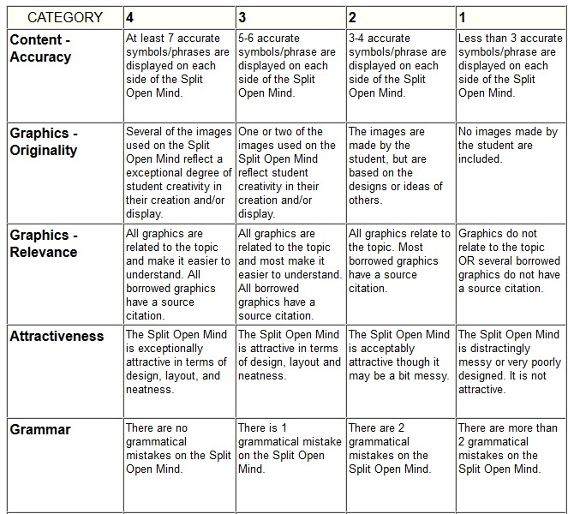
Total Points:____________/20

